IPAEA  Istituto di Psicoterapia Analitica Esistenziale di Ascoli | CIAC  Centro Internazionale Antropoartistico Counseling

TRAINING PROJECT

On the theme:

Experiential eco-system for entrepreneurial creativity
Based on the movie “Beauty and the Beast” by J. Cocteau (1946)

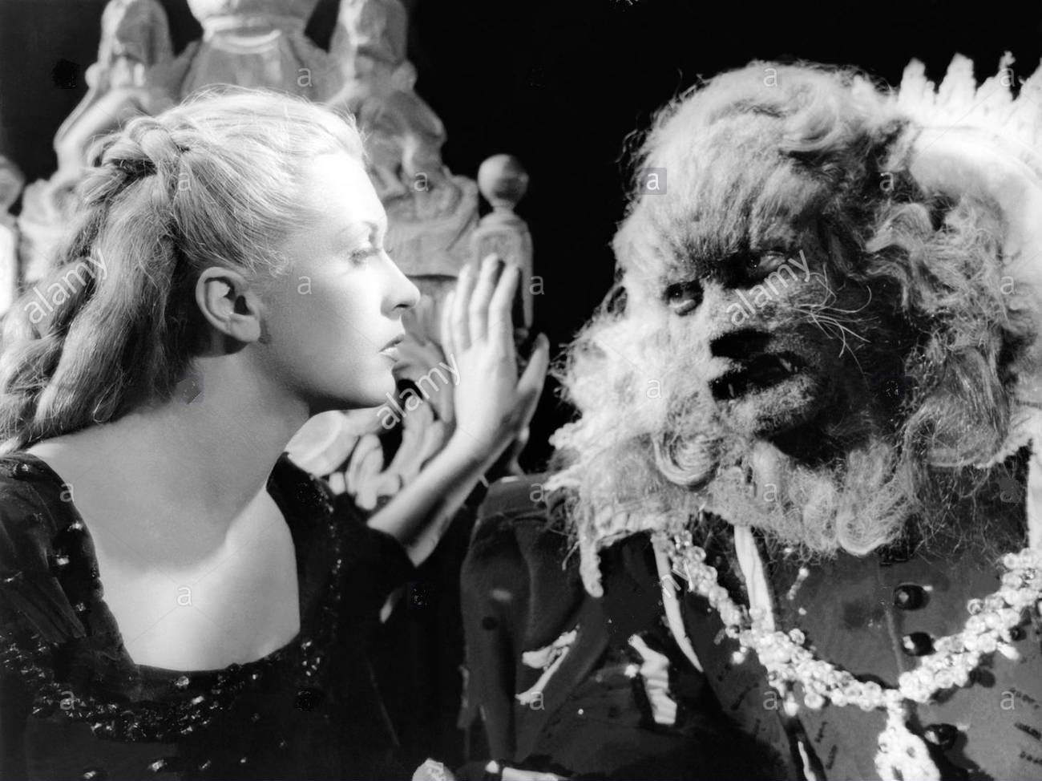

Scientific-cultural twinning Italy – Poland, 2018

Foundation VIVA FEMINA | Antroposervice Sas
COURSE PROGRAMME
MASTER Course on Anthropoartistic Entrepreneurial Creativity (CIAC)

SUNDAY 11 FEBRUARY
Time | Venue | Activity | hours
h 9.00 | Ascoli Piceno  Via dei Saladini | Vision of the movie " Beauty and the Beast " by J Cocteau | 2
H 11.00 | // | Lecture  Theme: Knowing ourselves. Discovering our masks. | 2
H 13.00 |  | Lunch break
H 15.00 | // | Lecture  Theme: Carnival of yesterday and today, the Mask and the AnthropoArtistic Theater Dance | 2
H 17.00 | Ascoli Piceno  Ancient Town Center - P.zza del Popolo | Carneval in Piazza del Popolo (typical carnival of Ascoli Piceno) | 2
H 19.00 |  | End of works

***
MONDAY 12 FEBRUARY
Time | Venue | Activity | n. di h
h 9.00 | Ascoli Piceno  Via dei Saladini | Lecture  Theme: knowing the others outside myself.  How do I relate to collaborators, clients, suppliers, family members?  Verbal and non-verbal communication | 2
H 11.00 | // | Lecture  Theme: non-verbal communication: the silence. | 2
H 13.00 |  | Lunch break
H 15.00 | // | Lecture  Theme: non-verbal communication: body language | 2
H 17.00 | // | Experiential workshop  with the AnthropoArtistic Theater Dance | 1
H 18.00 | // | Experiential workshop  with the AnthropoArtistic Theater Dance  Class of Argentine Tango | 1
H 19.00 |  | End of works

***
TUESDAY 13 FEBRUARY
Time | Venue | Activity | n. di h
h 9.00 | Ascoli Piceno  Via dei Saladini | Creative writing laboratory  Theme: the conflict.  Within the family, with others, at the workplace, with the collaborators, within the enterprise | 2
H 11.00 | // | Meeting group  Theme: debate and elaboration of what have been experienced through creative writing | 2
H 13.00 |  | Lunch break
H 15.00 | // | Lecture  Theme: Techniques for conflict management: mediation, negotiation, creative transformation.  The encounter between  Laius and Oedipus on the bridge | 2
H 17.00 | // | Experiential workshop  with the AnthropoArtistic Theater Dance  Class of Flamenco | 1
H 18.00 | Ascoli Piceno  Ancient Town center - P.zza del Popolo | Carnival in the Town center | 1
H 19.00 |  | End of works

***
WEDNESDAY 14 FEBRUARY
Time | Venue | Activity | n. di h | Docenza
h 9.00 | Ascoli Piceno  Via dei Saladini | Lecture  Theme: Entrepreneurship and problem solving.  The creative-artistic capacity and the “ottavina reale” *. | 2
H 11.00 | // | Experiential sharing  Theme: The “ottavina reale”. | 2
H 13.00 |  | Lunch break
H 15.00 | // | Lecture  Socialization  Theme: on-board diary, discovering our entrepreneurship | 4
H 19.00 |  | End of works

***
THURSDAY 15 FEBRUARY
Time | Venue | Activity | n. di h
h 9.00 | Ascoli Piceno  Via dei Saladini | Lecture  Theme:  Project and action as engines for the entrepreneurial success | 2
H 11.00 | // | Socialization and sharing  Theme: which is my talent?  Which is my project? | 2
H 13.00 |  | Lunch break
H 15.00 | // | Experiential workshop  with the AnthropoArtistic Theater Dance  Theme: discovering our talents. Various arts between the saying and the making... | 2
H 17.00 | // | Experiential workshop  with the AnthropoArtistic Theater Dance  Class of Flamenco and Argentine Tango | 2
H 19.00 |  | End of works

***
FRIDAY 16 FEBRUARY
Time | Venue | Activity | n. di h
h 9.00 | Ascoli Piceno  Via dei Saladini | Lecture  Theme:  Chorality as the main road to the entrepreneurial success.  The Land of Feaci. | 2
H 11.00 | // | Lecture  Theme: Art, Culture, Nature and Environment.  The Festival of the two Parks as example of a new sustainable entrepreneurship | 2
H 13.00 |  | Lunch break
H 15.00 | // | Experiential workshop  with the AnthropoArtistic Theater Dance  conceiving a performance  Theme: Synthesis and fusion between the Beauty and the Beast | 2
H 18.00 | // | Experiential workshop  with the AnthropoArtistic Theater Dance  Class of Argentine Tango | 1
H 19.00 |  | End of works

***
SATURDAY 17 FEBRUARY
Time | Venue | Activity | n. di h
h 9.00 | Ascoli Piceno  Via dei Saladini | Creative writing  Theme:  What I leave and what I bring along... ON-BOARD DIARY | 2
H 11.00 | // | Experiential workshop  with the AnthropoArtistic Theater Dance  theater performance  Theme: Synthesis and fusion between the Beauty and the Beast | 2
H 13.00 |  | LUNCH AT THE SEASIDE: TASTING LOCAL SEAFOOD
H 15.00 | // | Staging of the Performance | 1
H 16.00 | // | Mammut GROUP (final meeting to connect “alll the wires”) | 3
 |  | End of works

- Ottavina reale: in the Italian pool, it is a special and very difficult shot in which the ball hits 8 times the pool sides before hitting the central pin. Within this programme is has to be intended as the “genius solution”.

PROJECT SUMMARY

Overall objectives
The aim of the project is to empower skills and competences of educators, vocational guidance specialists, psychologists, work trainers working and volunteering in foundation Viva Femina; to raise their readiness to implement innovative training methods, to increase their motivation and commitment to learners;
to better inspire adult learners;
to equip the staff with new knowledge and tools. What is more important raising the staff's well-being in order to better use their own potential in adult education, to have more work satisfaction and to prevent their professional burnout;
to equip the staff with original and innovative knowledge especially as regards the developing of entrepreneurial creativity and skills.

Specific objectives
-To give trainers the opportunity to develop their own teaching skills, methods, attitudes. Through this project they will get new ideas how to do their teaching in a new way, with a more international approach.
- To deepen our co-operation with our partner in order to have different projects in the future. It is important that trainers would have the opportunity to establish personal and professional relationships with new colleagues in other Countries.
- To develop the training department especially in the perspective of internationalization.
-To strengthen the trainers self esteem, also in regards to English proficiency.

Methodology
The training course makes available through a direct experience in accessible ways, a unique mesh-up of knowledge developed by different disciplines and different scientific fields in recent decades, not just in relation to intellectual-cognitive learning capacities, but also and above all on the intellectual-relational and communication abilities, to favor the construction and representation of an inner experience with new contents and explicit and implicit communication tools, able to produce not just the “contagion” of ideas, but also the “contagion” of motivations and good-sense to realize something that was not there before, even when and where there are no economic support or investments available.
The course contents are offered through a "metaphorical systems" taken from art languages (cinema, theater, dance, novels, myths, etc.), always starting from the vision of a movie, chosen according to its universal contents, with an initial key to understanding, favoring the origination of ideas and experience as the “raw material” that will gain a defined shape along the course activities.
Participants will be conducted through the discovery and acquisition of the original methodology, as well as the possible paths of integrating it in their respective teaching processes and environments.
The training course is organized over a 7-days experiential laboratory, mixing theoretical, practical and experiential learning. Over the 7 days the following contents will be explored and offered.

Contents
The fusion of the opposites is possible: learning how to make use of the black and white keys of a piano in harmony, supporting at every stage critical thinking focused towards a possible synthesis of internal or external conflicts and obstacles.
Giving shape to creativity: experiencing different expressions of individual and choral creativity: creative-writing, video making, dance and music and learning how to translate it in the conception of culture, art, sport, tourism events and innovative businesses in creative fields.
From Research to Action: learning the transition from a cocept/idea to the action. From the incubation of ideas, to the goal setting and fixing the route, oriented to the valorization of human and natural resources for the sustainability.
Dialogue with reality: learning how to query the reality around us: assessing the potential, the risks and possible solutions when the idea begins to interact with reality; how to interact with focus groups to analyze and overcome critical situations, how to share strategic choices and decisions. Analyis of results and outcomes is vital at every stage of a process, to fine tune and adjust the route.
The solar system: learning how to recognize energies and resources around us, how to build alliances (or to avoid destructive complicities.
Circular thinking: learning how to interpret and converge different thinking as radius of the same wheel favoring the interaction of the emerging energies (and people) of yesterday, today and tomorrow, for continuity.

EXECUTIVE SUMMARY

Theme
The Carnival yesterday and today, the mask and the Anthropoartistic Theater Dance

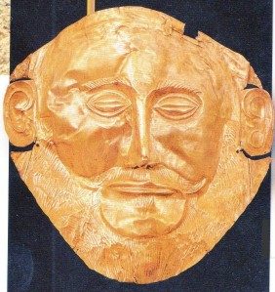

Historical and anthropological summary

Overview of the carnival of Ascoli Piceno
The Carnival in Ascoli Piceno has a long tradition over the centuries. Originally linked to the propitiatory rites of spring, over time it has evolved into a popular festival linked to entertainment, satire and goliardic spirit; this, however, has not distorted the original ritual essence, as will be explained later.
The Ascoli Carnival is really felt by the population: all citizens become actors and the whole city turns into a theater, especially the ancient town and the main square Piazza del Popolo which is decorated with huge chandeliers that create a festive and surreal atmosphere. The preparation of this atmosphere begins some time before and there are three stages that precede the so-called “Fat Tuesday”, namely:
- the Sunday of friends;
- the Sunday of relatives;
- the Carnival Sunday.
The days of celebration culminating the period are the so-called “Fat Thursday”, the carnival Sunday and the “Fat- Tuesday”.
The celebration in Ascoli along with other events in nearby places (in the villages of: Offida, Castignano and Pozza) give life to the so-called "Piceno historical carnival".

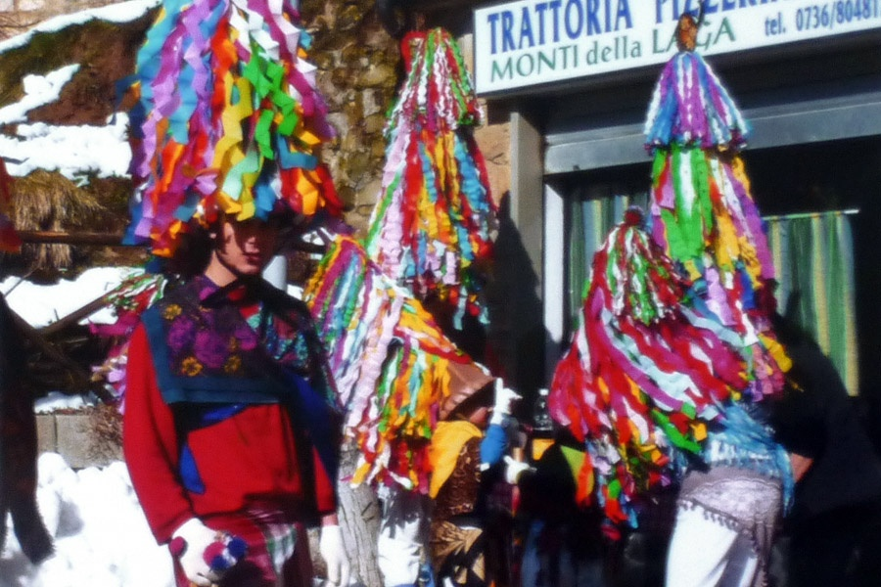 | 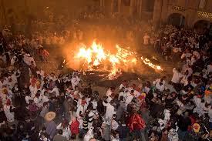
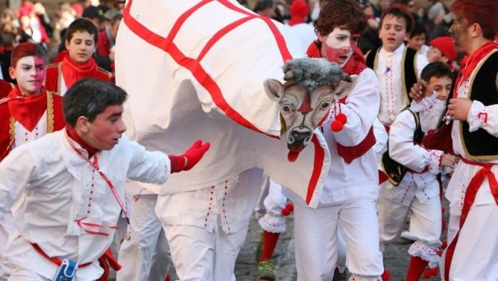 | 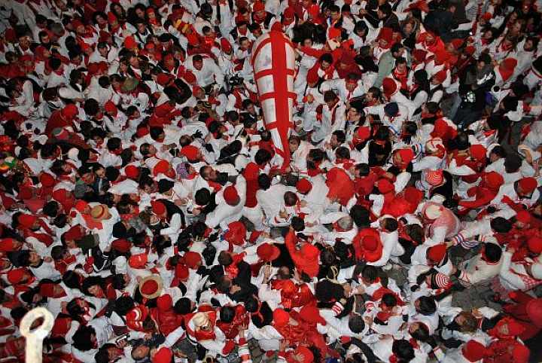

It is a Carnival that differs from the national scene. Elsewhere, entertainment has its fulcrum in the parades of allegorical chariots as in Viareggio, or in the parades of rich and elaborate masks like in Venice. The Carnival in Ascoli Piceno, on the other hand, is represented by a mask called "Lu Sfrigne", that is, a ragged one that is sheltered under an umbrella with hanging herrings.
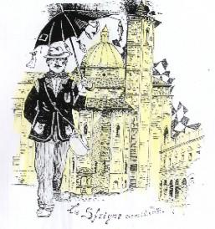

This mask says a lot about the diversity of this Carnival in which the nature of entertainment and the type of popular involvement are very different. A note stands out and the observer catches it beyond the general fun. It is the strong sharing of people.
The city becomes a theater stage and the masked citizens become actors, alone or in groups, all together they give life to a wild and kaleidoscopic flourish of sketches everywhere, often recited in local dialect, which are meant to amuse, to reflect and above all, to involve other masks and visitors. With all of them, the actors of the popular sketches continually interact, calling them on stage. There is a continuous exchange of dialogues and roles, in the name of satire and irony.

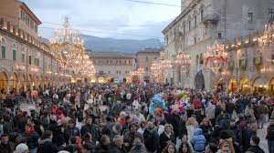 | 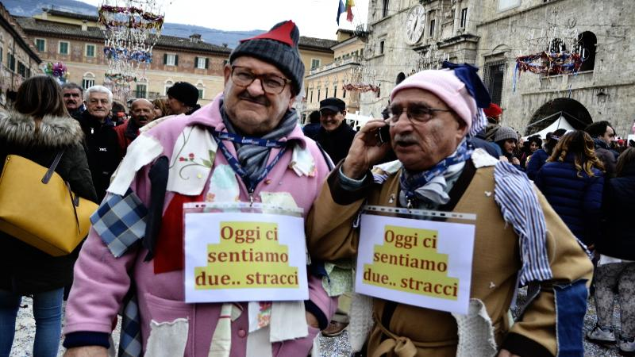

You’ll not witness the showcase of gorgeous masks like in Venice; the irreverent popular initiative is the master and targets well-known local and national characters, a mayor, a councilor, a minister, even the current social phenomena and trends.
For instance, in one of the most recent editions there was a sketch titled "Tom Satellità", inspired by the use of satellite navigators. At the epoch a GPS navigator called Tom-Tom was in vogue, where in the local dialect of Ascoli Piceno, “Tom” is an epithet naming someone who has scarce intelligence; so they staged a sketch having as protagonist a person dealing with a GPS navigator (the navigator was itself impersonated by another actor), who finally got lost in the town streets.
Creativity in this Carnival is an embroidery of irony and popular self-irony based on inventiveness that does not use great means, but uses satire along with a powerful choral action.
The masked groups as well as the masked individuals (called “macchiette”) take part in a competition where the best idea, the inventiveness, the most original costumes, the most satirical topic of sketches and representations, in the town ancient streets, are rewarded. For this reason the Ascoli Carnival is considered a declination of the tradition of the “Commedia dell'arte”. It is no coincidence that during the Carnival Ascoli holds, in the town main theatre, a review of the “Commedia dell'Arte”.

Notes on the origins of the Carnival
The Carnival is a festivity, especially celebrated in Countries with Catholic tradition, whose origins are, however, much older than Catholicism and are rooted in antiquity. The element characterizing the carnival is the masquerade, the disguise.
The word Carnevale comes from the Latin "carnem levare" (to eliminate meat) to indicate the banquets held before the beginning of Lent (the 40 days period preceding Easter), on Thursdays and Tuesdays, for this reason called "fat". For the occasion, each town and village offers typical culinary specialties of the period, for the most part sweets.
The origins of the carnival can be rooted in the Dionysian rites of ancient Greece as well as in the Roman Saturnalia. During these feasts it was allowed to release the tension of social obligations and hierarchies of power, to leave space for a reversal of the established order, for jokes which could also reach debauchery and orgies.
It was a period of celebration that marked the end of a cycle and the beginning of another one; the moment of passage was celebrated with a symbolic rite of renewal, in which chaos prevailed, putting itself in the place of the established order. Once the celebrations were over, nonetheless, there was the restoration of the order, that was renewed and ready to govern a new cycle.
These were propitiatory rituals with a mythical value to celebrate the Earth fecundity. Cyclicity referred to the terrestrial and solar cycles (equinoxes, solstices, seasons, etc.). Even in past eras, masking was typical of these periods. For the Romans, the year that ended was represented by a man covered with goat skins, carried in procession and struck with sticks. The presence of masked groups is evidenced by Apuleio (book XI of Le Metamorfosi).
During the Greek Dionysiacs (antesterie) the chariot, carrying the one who had to restore the Cosmos, passed through, after the return to the primordial chaos that precedes every creation and every manifestation of organized forms. Similar celebrations took place earlier in Egypt and in Babylon, with masks, chariots and processions. All allegorical rites that represented the refoundation of the Universe (cosmogony) and the renewal. These were rites of death-rebirth.
In the book "The myth of the eternal return" the historian of religions Mircea Elia describes: "Every new year is a re-start of time at its beginning". Hence such rites express a deep need to regenerate periodically, abolishing the time spent and reactualizing the origins. The abolition of the past is expressed through the confusion of forms as well as the upsetting of social conditions. During the festivities everything is permissible, because every order must be broken so that it can be renewed: the slave is promoted to master, the master serves the slaves. In Mesopotamia the king was deposed and humiliated.
Suspended all the rules, the licentiousness and the violation of prohibitions are unleashed; this aims at the dissolution of the world to give it a magical way, to compose itself, to recreate.
However, the annihilation of time and the return to the origins, breaking every barrier, also breaks the one that separates the living from the dead. Broken the boundaries between the accomplished forms and the larval ones, the dead’s souls break into the present; in order not to let them being dangerous, it is necessary to honor them, lending them provisional bodies: the masks, indeed. Those who wear masks assume the characteristics of the larval or supernatural being or of the represented defunct.

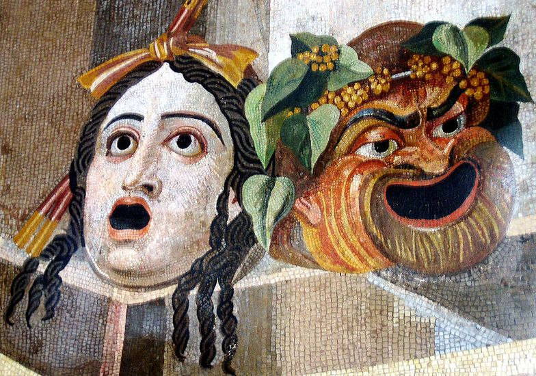

It is in this way that the first forms of theater as well as the use of masks in ancient Greek theater are born, which then uses masks also for a technical reason, since through the mask the sound and the voices of the actors you can amplified (a sort of megaphone).
It should be noted that the etymology of the word “Persona” comes from “per-sono”, referring precisely to the resonance of the Greek mask through which the actors spoke.
The etymology warns us that people have masks. It’s the masks studied by psychology (e.g. C.G. Jung), through which we show ourselves to the world, hiding our true nature or our intentions for the most varied reasons: we are ashamed, we want to look better, we do not want to be blamed, etc..

Note: The loosening of control and social constraints let the drives being mainstreamed; this in itself evokes the same effect of the wit, which is liberating, fun and festive. Suffice it to think of the festive feeling of when our parents gave us a license from the usual duties, for example, we could leave the house and return later. It seemed like a "breath of freedom" because the time of everyday life was broken and you could see in its place, new possibilities.

Bibliography
Mircea Eliade, The Myth of the Eternal Return, Gallimard, 1969.
Mario Colangeli, Anna Fraschetti, Carnival: the places, the masks, the rites and the protagonists of a crazy, disturbing popular feast, Lato side, 1982, Sitography: Wikipedia - Carnival

Cultural roots

At first, let us introduce what our cultural roots are, which refer to the Personalistic Existential Anthropology and the Theory of the Person founded and created by Antonio Mercurio, student of Erich Fromm and also founder of the Sophia-analysis, Sophia-art and of Cosmo art. This thought has been developed in Italy by the Institutes of the Sophia University of Rome (SUR) and by our founder Dr Italia Gabriella Sorgi. She is credited with having developed the thought of Antonio Mercurio worldwide, applying it in the field of psychotherapy and counseling as well as in other areas. Thanks to her studies and research Dr Gabriella Sorgi has received prestigious international awards. The originality of the psychotherapeutic method of the Analytical Theater Dance created by herself is accredited and recognized by the Italian Ministry of Education, University and Research (MIUR), protected by a special post graduate school of specialization in psychotherapy, enabling to the practice of the profession of psychotherapist in Italy.
The idea of ​​these works is inspired by an international seminar that was held by the founder of the institutes IPAEA and CIAC, Dr Sorgi, in the town of Ascoli Piceno in February 2003 (many others followed over the years), within the scientific-cultural twinning between the Institute of Existential Analytical Psychotherpy of Ascoli (IPAEA) and Psychotherapy Professional League of Russia (PPL), that had already started up years earlier.
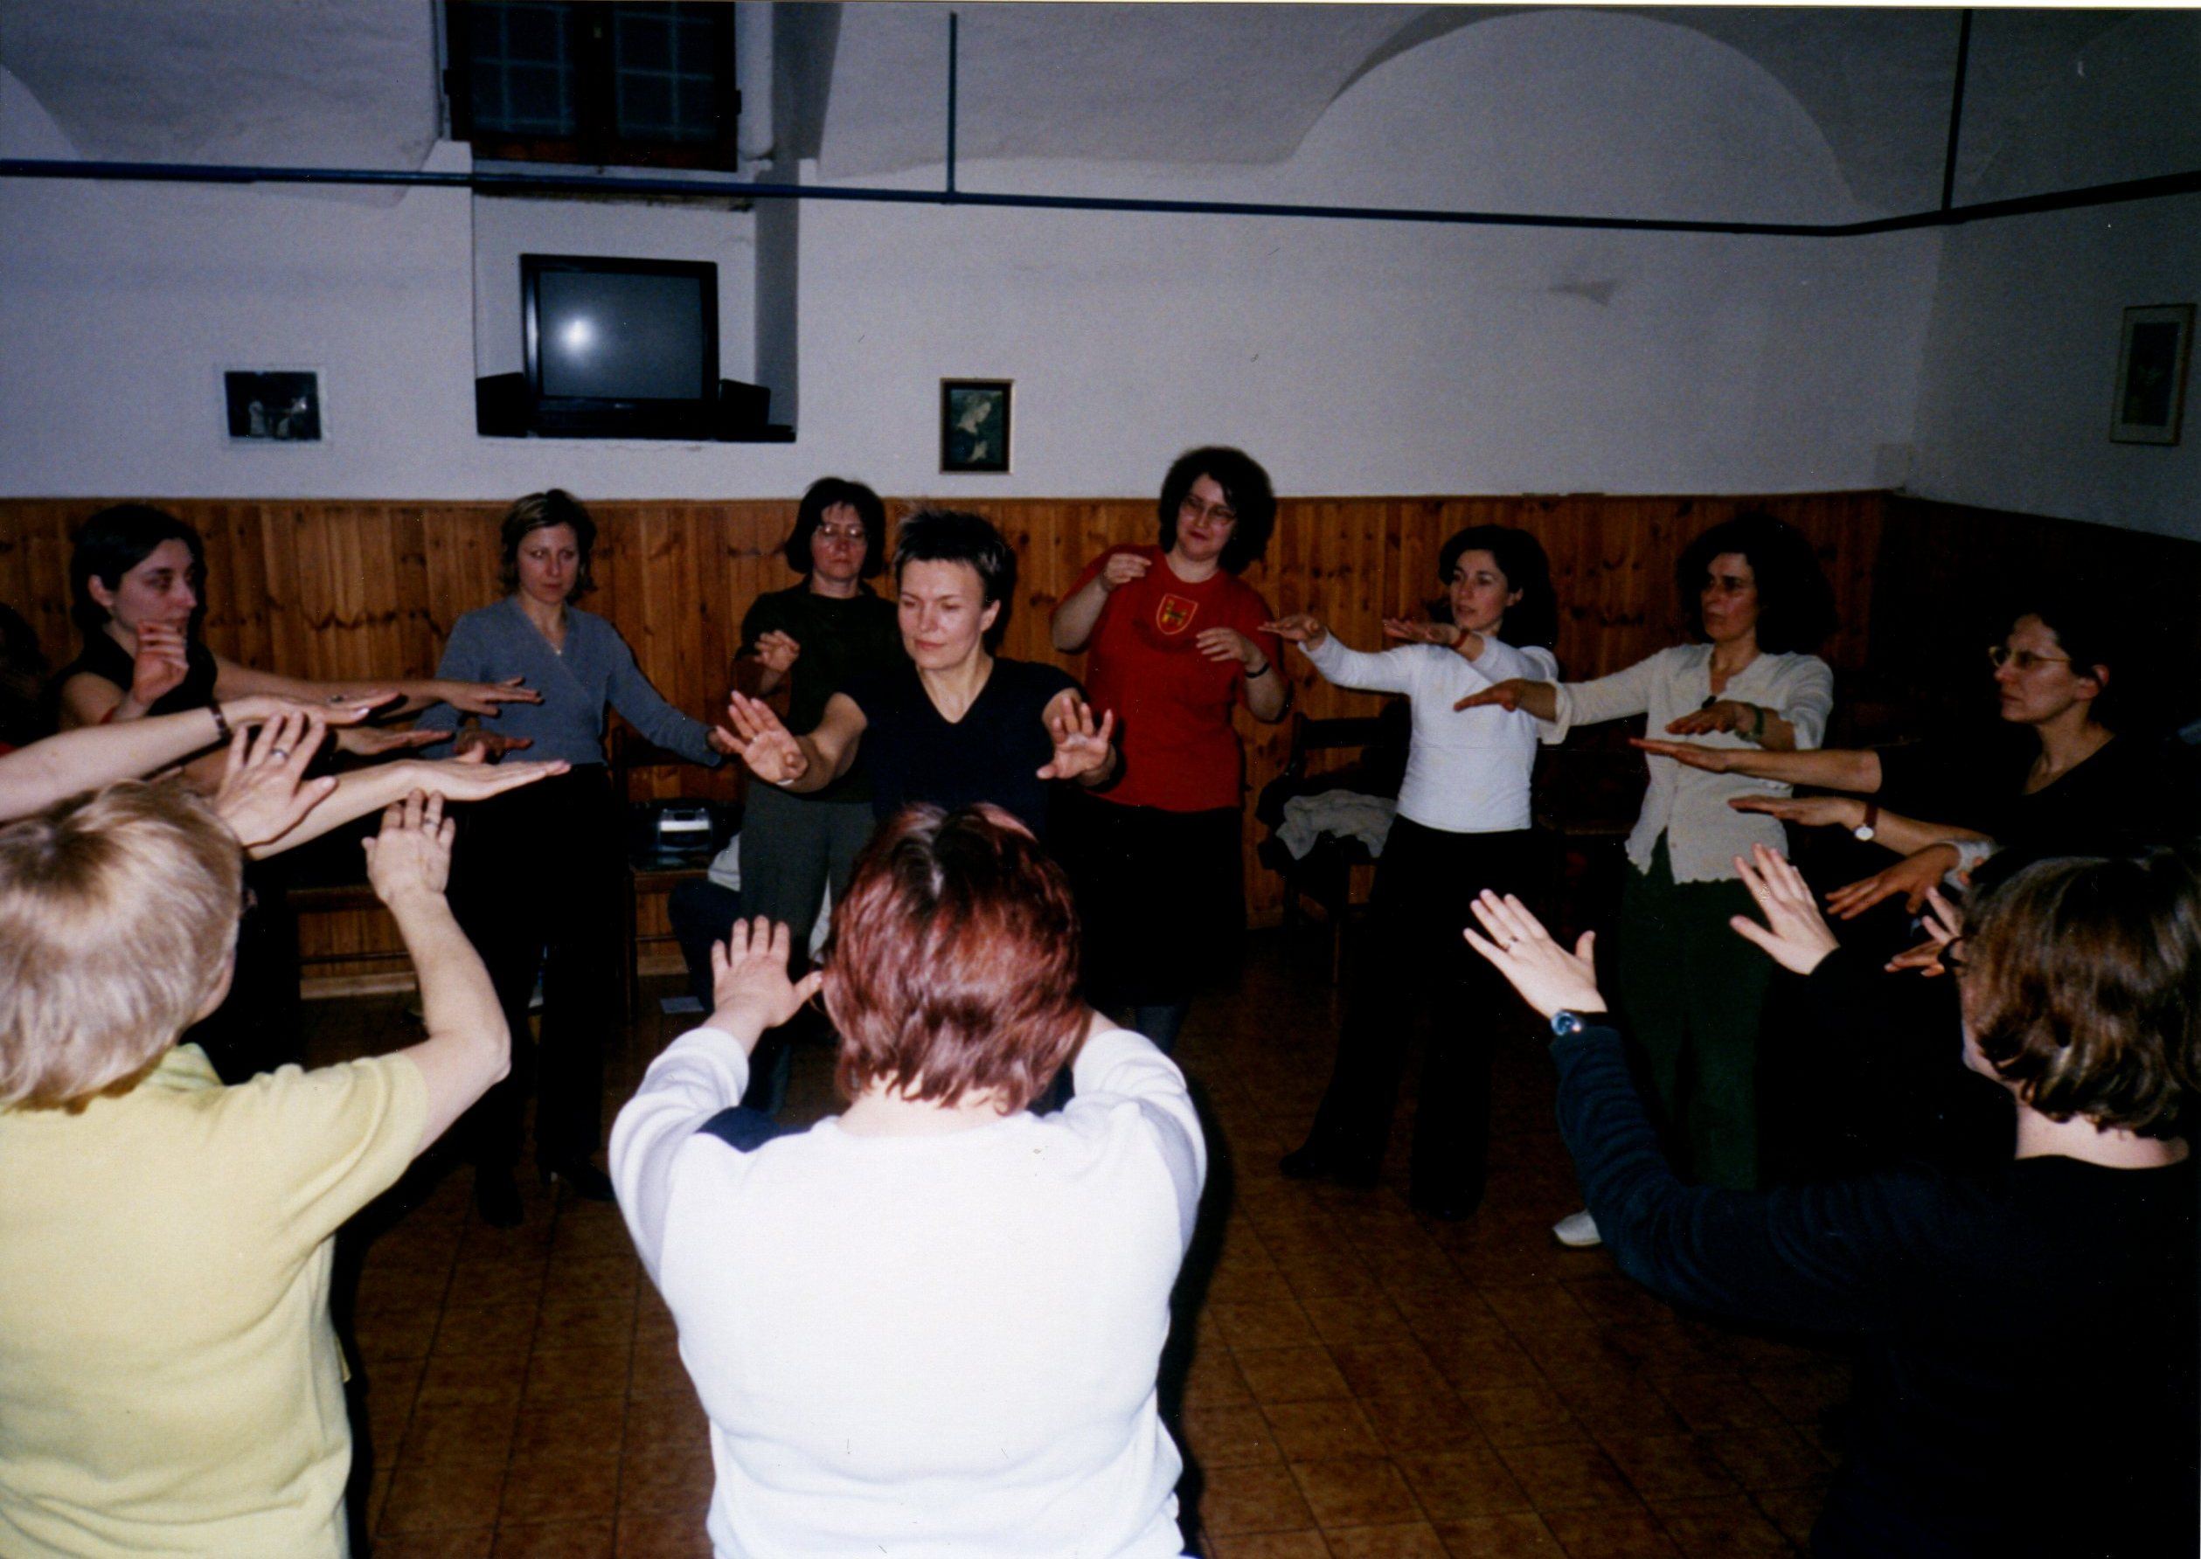 | 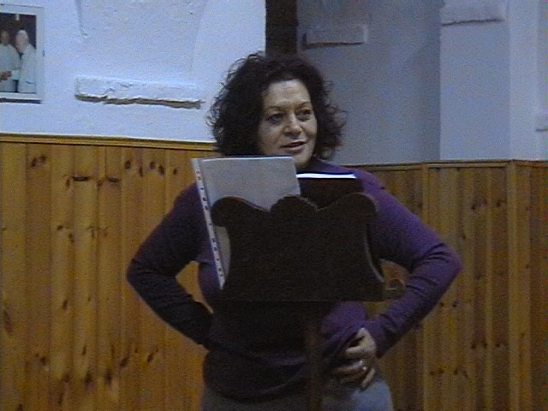

At that seminar (as well as at the following ones), delegations from all over the world took part, especially from the former Soviet Union Countries, for training and professional updating. The “anthropoartists” of the Centre International Anthropoartistic Counseling (CIAC) also take part to the seminar works for training and professional updating themselves, both to learn new contents and to lay on the fields those already learned. For instance, during seminars, the “anthropoartists” are in charge, with competence, of the logistics, accommodation, social events (cultural-artistic tours, gala evenings, etc.), organizational secretariat, visas, agreements, documents and so on as well as of the activities during the creative workshops such as: Flamenco and Argentine tango, events planning, staging and representation of theatre plays / performances taken from the settings of the Analytical Theater Dance by Dr I.G. Sorgi.

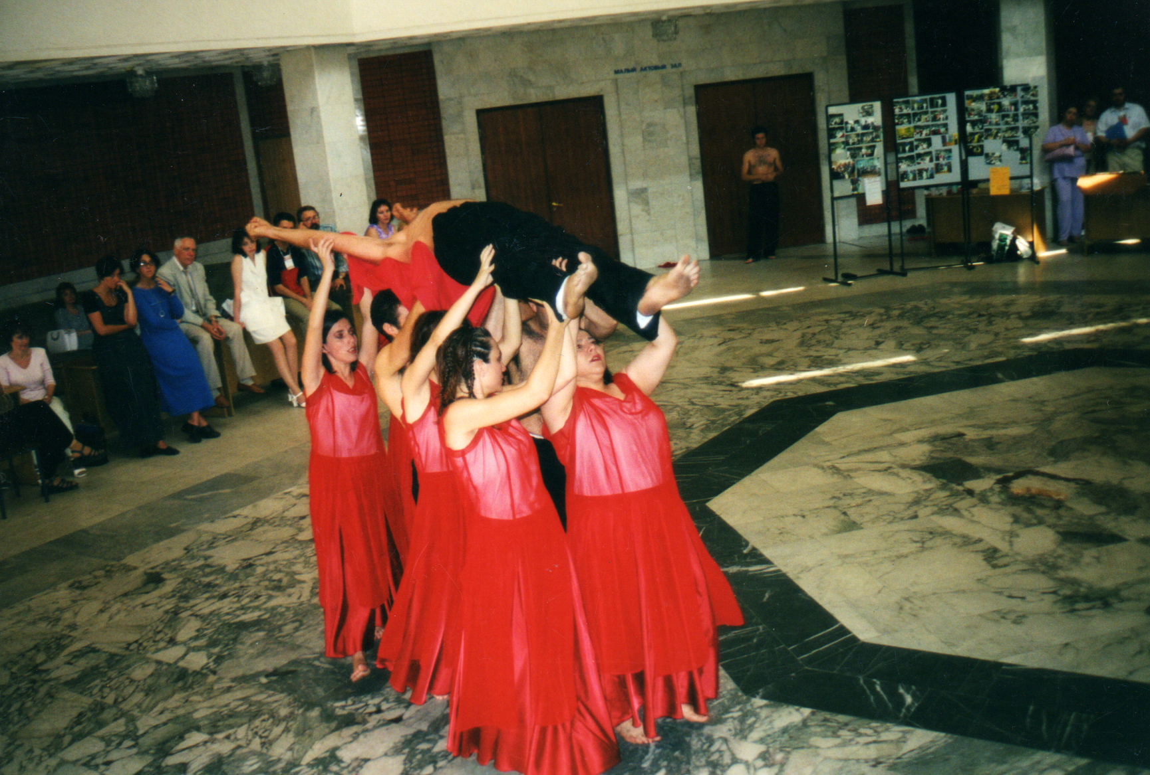 | 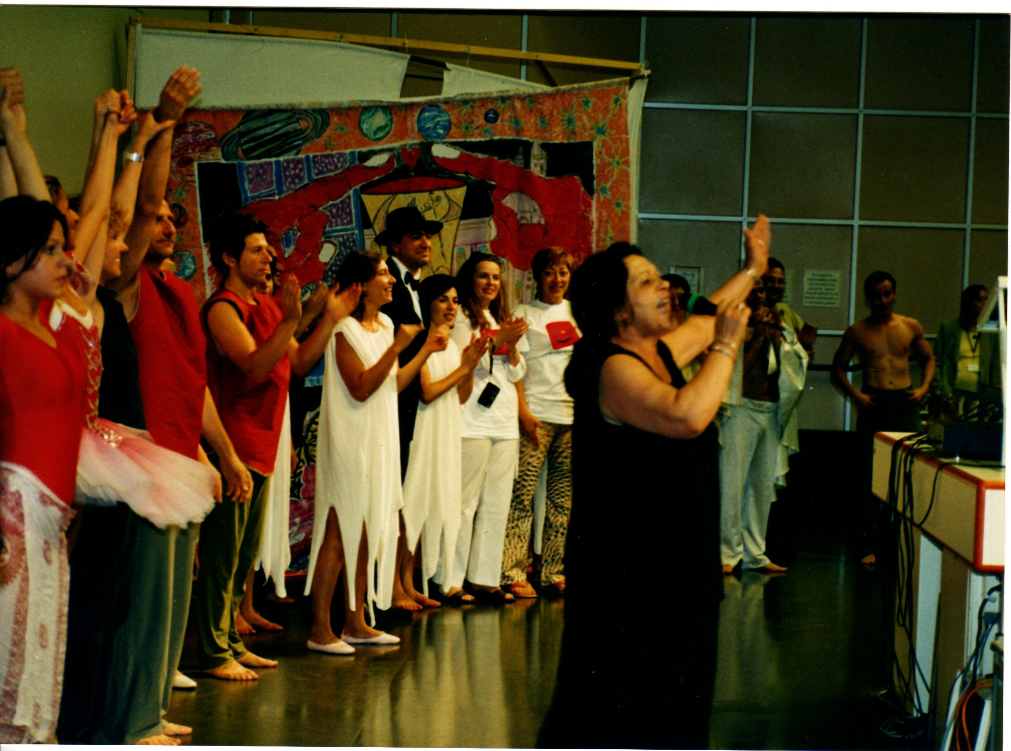

Hence, our training is very serious and demanding, above all I would say that it is training characterized by creativity and the four fundamental values: Freedom, Truth, Love and Beauty, which are the fundamental values ​​of life, we believe.
Our task, even today, is to witness these values, expressing and sharing them, eventually merging them to create, along with others, Beauty. It is Beauty giving life to an entrepreneurial or existential project, etc. finding the necessary energies to realize it with the choral help. Starting-up a project is like undertaking a journey. You need to set the goal first, then find a map, plot a route and follow it day by day, sometimes by land and sometimes by sea.
The route has to be kept and adjusted, knowing that good teachers are needed as well as good travel companions to rely on, sometimes.
When the path is completed, when honestly and without deception you have reached the goal, it may be possible that you feel light, happy, sunny. If you feel joy and you’re able to share it, then it means you were also capable to fly, that is, you have created beauty for yourself and for others.
Is there anything better in life?
If someone is looking for something better then she/he has come to the wrong place, because that’s what we’ve been taught and that’s what the anthropoartists attempt to do.
We anthropologists have been taught a new way of seeing ourselves, the others, life and things. We’re proposing it to you, hoping you can find it interesting and it might be useful for you at least a tiny bit, to realize your projects: family, life, couple, work, experiential.
In the journey of these works, "the map" will not the programme itself, that will be certainly folowed, rather it will be the movie "The Beauty and the Beast" by Jean Cocteau, 1946. It’s a movie that seems a fable and speaks of transformation.
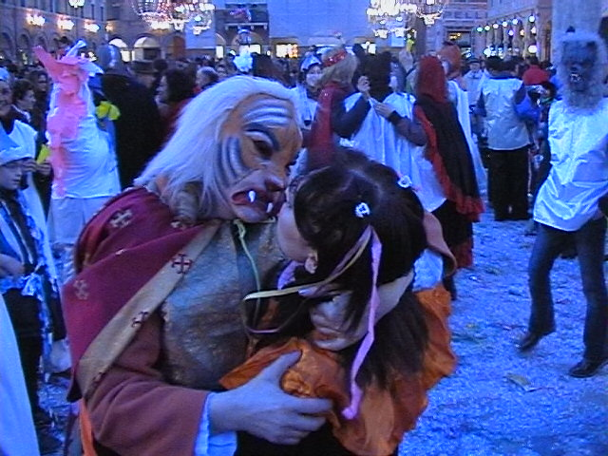

We will work on the movie as our Maestro Dr I. G. Sorgi taught us, showing how we can seize it and attribute to it a meaning for our lives, aware that that meaning is valid for today and is never the same as yesterday; that we will have to rethink it tomorrow, since life, tomorrow, will give new brush-strokes to our existence and we will be in other places, in other situations, with other people.
But what we’ll have learned together, today, is a map nonetheless. And if the map is not the territory, at least it can guide us, it can offer us points of reference to follow so as not to risk getting lost.
We will see how in the film, we can see our conditions, our intuitions, our emotions, our dreams and projects, and also good indications to be able to achieve them.
It seems strange? Maybe it is.
However, please consider that Cinematography is an art, the seventh to be precise after Architecture, Music, Painting, Sculpture, Poetry, Dance.
Art has a characteristic: it always surpasses us; it is something that goes beyond us (ecstasy = ex-stasis). No matter how we can think of art and its languages ​​in various ways, the true essence of art remains this. We will make use of this feature to try to "go beyond" our borders and see new perspectives, be them near or far, towards which we can orient ourselves. And then, even intuitively, everyone knows that Art and Creativity go hand in hand.
Do those, who want to be entrepreneurs, need art? Even this may seem strange and difficult to target without experiencing it.
We can tell you, for a methodological assumption we have learned, that Art has to do with it everywhere. For instance, Dr. Sorgi has spent herself so much to tell the world that Psychotherapy is an Art and this, in her field that apparently has nothing to do with Art, has allowed her to create an innovative method that did not exist before.
Art can be useful in any human sphere. Why? How?
We use to say that we are not born "learned". If you notice, most of the time in life we ​​happen to not know what to do, which way to go, what decision to take. This is also true while performing our work that we are trained and prepared to do.
That’s why life always surprises us and let us face unexpected situations that we had not studied in school books. It seems like our lives are unique and inimitable, different from others. Indeed it is. We are unique and original because we are Persons (recall per-sona).
This sometimes can make us angry. For instance in your couple you’d like things to go in a certain direction, but they do not go as you expected, or you have a profit-less activity, or an unexpected problem presents in front of you, surprising you, wearing you down, putting your back to the wall.
What to do? By chance do you think you can find somewhere a ready to use recipe, that quickly gives you the solution? Not me. For this reason, by looking for solutions in vain for a long time, in the end I came and stayed here.
Let's go back to Art and say what it can do in these cases. If there isn’t yet a recipe ready for our case, if what others suggest us does not work, there is only one possibility: we have to invent it!
Can you understand how is creativity helpful in a person's everyday life, at work, in the family, etc.?
Someone could say: “How can you invent a solution?
Someone else might think: "the solutions others apply do work, maybe I'm more unlucky or stupid and I do not understand them". However it is, either you’re resourceful or you crack. At this point you are fragile and impotent (you can not solve the problem, you can not overcome it), you are so depend on the solution that you beg anyone who can help, even those who strong of your fragility, transform your need for a solution in a need of themselves. Nice rip off! Where is the solution?
Seriously we look at the past, at human evolutionary history. Anthropological thought helps us understand how everywhere in the world, faced with problems, man relies on one of the four driving forces of Civilization: Religion, Science, Philosophy, Art. These, from time to time, have elaborated and provided their answers, allowing progress and civilization. Despite all this, the world is not perfect (the answers are not exhaustive). Not rarely, the answers that come to us from one side or the other are conflicting. Let us consider, for example, how much mistrust the Darwin's theory of evolution, has faced, since it contrasted with the idea that God created us; think how the scientific progress with the studies on nuclear energy has led us on the brink of mass destruction, instead of just supplying energy to everyone. When a scientific solution (Science) or true solution (Philosophy) is not there yet, when you are in a dark moment and your faith (Religion) falters, there is only one solution left: art.
Art has no dogma as religion has, it does not ask you to be silent if you can not think, it does not ask you to prove anything. Art does not judge, it transposes and transforms and you can imagine what you still are not able to do.
Antonio Mercurio says that without imagination there is no creation.
Maybe it's just a daydream, but in the meantime this is already a consolation, we all know.
If then someone teaches us how to move from imagination to creation, from idea to action, then it can become a good thing.
That's why we work on films. What is a film if not a daydream in which we can identify ourselves?
Now, can this old movie tell us something new?

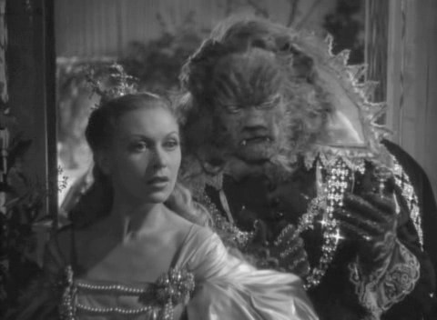

Not only is this movie old, also the story is very old. “The Beauty and the Beast” has very ancient origins that can be traced back to Apuleio (Love and Psyche). The fable resumed a literary shape in 1550, thanks to Francesco Straparola who included it in his book "Le piacevoli notti" (“The pleasant nights”). It later came to the canonical elaboration made by Jeanne Marie Leprince de Beaumont (1740). We owe to this female author this modern tale we all know, which she composed by reducing a previous version by Gabrielle Suzanne Bardot de Villeneuve.
The Beauty and the Beast is a millenarian and universal history that deals symbolically, the fulfillment of the Being, also touching the oedipal aspect. The fortune of this tale is due to its many and profound signifiers that have earned countless translations, reviews, tributes. The director J. Cocteau makes a particularly "dreamlike" adaptation out of it, given the masterly plays of lights and symbols he puts on the pitch. In the film's headlines, he invites us, adult spectators, to let ourselves immerse in the magical words of childhood and ingenuity, then the path in which he guides us proves how difficult it is to distinguish fantasy from reality.

Hints and reflections on the figure of the entrepreneur

What does this movie have to do with entrepreneurial creativity?
What do we know of the being an entrepreneur?
Commonly an entrepreneur is defined as the one who holds productive means (capital, means of production, labor force, raw materials) through which managing economic activities and investments. Entrepreneurs take the so-called business risk to develop new products and services, new markets, new means of production, thus contributing to the creation of new wealth and new value in the form of goods and services useful to the community.
The term entrepreneur appeared for the first time in Europe around 1500. That’s how the captain of fortune, who engaged troops to serve the needs of princes and powerful ones, was renamed.

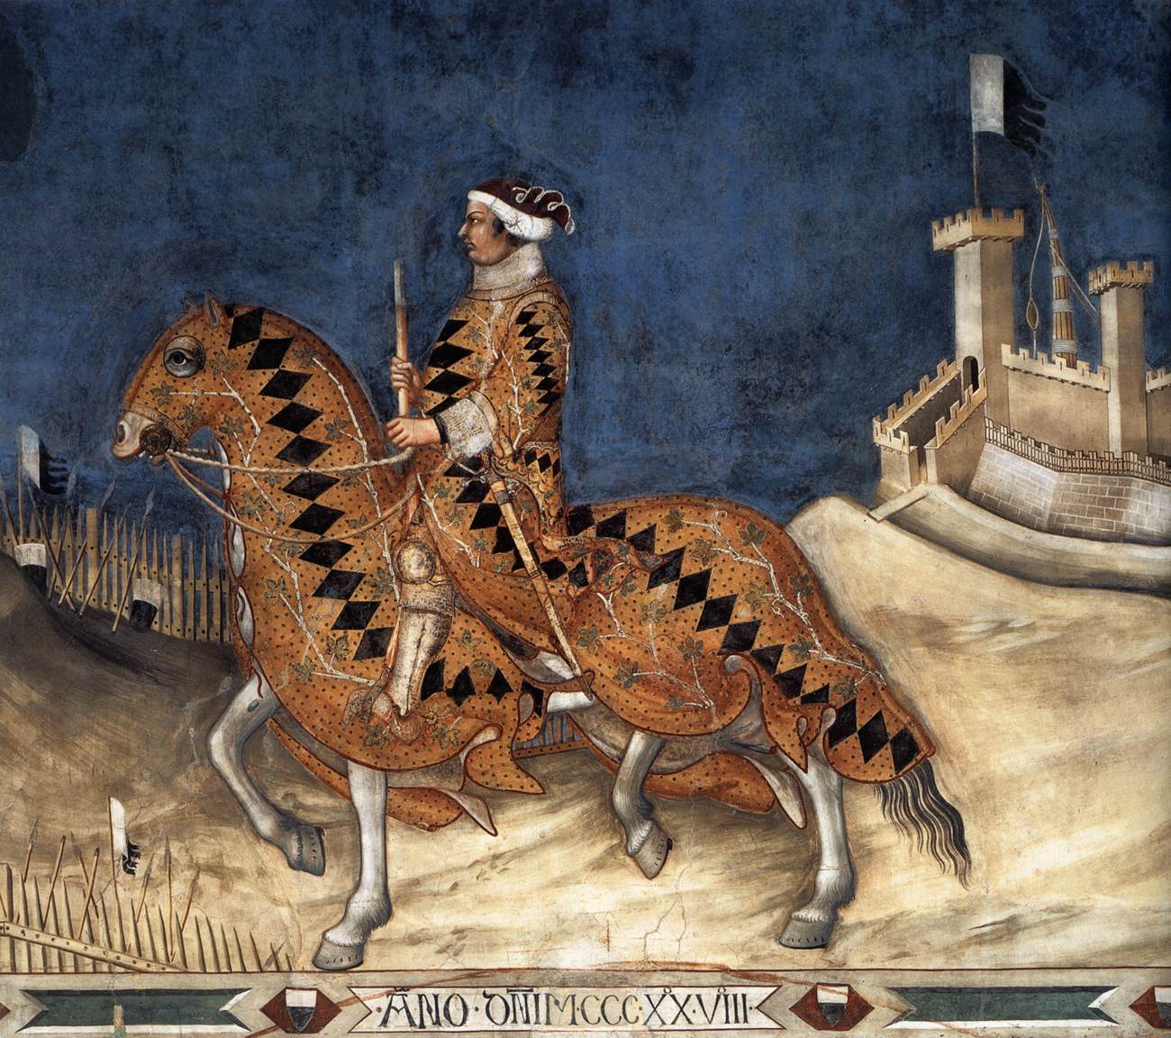
In the 18th century, with the industrialization, the figure of the entrepreneur assumes the modern connotations. The English definition of undertaker comes out, meaning the one who takes upon himself the responsibility of carrying out a work that requires the engagement of several people, implicit still today in the meaning of the term.
Therefore, there are two aspects to the origin of this term: the first one brings us back to the captains of fortune, that is, evoking warriors and mercenaries, wars and battles; the second one evokes complex dimensions such as doing (know-how), responsibility, collectivity (work and commitment of several people).
Is there still relevance in these aspects? We are inclined to believe so.
When things are born you give them a name and, sometimes, the name ends up confusing with the identity.
For example "I am Fazia". It is easier for me to say this, than tell you who I am.
The idea remains that the entrepreneur should be a bit of a warrior and everywhere in the world there are courses to become entrepreneurs, teaching "strategies" (the strategist is a military); even today great entrepreneurs are often called captains.
There is a risk in this and few see it. Economic theories report it without being able to remedy it. One of such theories says that it takes only three generations to squander any fortune accumulated by men, no matter how great it is. Money and goods are the most volatile matter that exist.
Where is the person in all this? Is it a commodity herself? Is it just a consumer? What representation of the human being comes out of it?
The consumer is a devourer, he is a beast.
Everyone in the film worries that Beast will devour them, even Beauty.
Beauty's father is a successful trader, but he loses his ships with all the goods. His children, regardless of his fate, continue to squander and pretend from him, more than he can afford.
Where is humanity placed in the Market?
The market, especially the current global one, has to deal with the ruthless competition and often with the lack of ideas. Entire economies of some Countries are wrecked and many people end up in poverty, even here in Italy.
You can sell the family jewelry, the national jewels (like the prestigious companies that are sold or relocated) to maintain high standards of profit, productivity and competition.
The same is done by Beauty's brother, who loses to the game, hypothecate the house furniture that is taken away. Beauty's brother is a gambler.
Is the economy a gamble? Sometimes it can be when an investment is just a lottery. It is called Business Risk. But the real risk is to be blinded by envy and insensitivity that we see in the faces and actions of Beauty’s sisters, brother and pretender, which are those of Beauty herself.
We can all see the obvious danger of competition, it is the danger to fail. So we think that strategies can come to the rescue. But it is not a good strategy the omnipotence that does not take into account the human factor, of humanity within us, of our being Persons rather than commodities or consumers.
In the movie we can see the children’s carelessness, with the exception of Beauty, with which they continue to pretend that their father keep their lifestyle, without getting busy, without letting him feel the minimum empathy for the misfortune and loss occurred.
Why does this happen?
It is called Claim. I pretend that you satisfy my needs; I claim to be served as a queen or a king; I pretend that life is beautiful, it is my right and I decide that you have to give it to me as I want it. Beware if you do not do it. You have to serve me: servitude is the scepter of my command over you (power over); you will be my succubus and I will have you in my hand.
This is a childish idea of power as well as of enjoying. A so-called godsend in the land of plenty where nothing has a cost for us and where we owe nothing, but everything is due to us as when we were children.

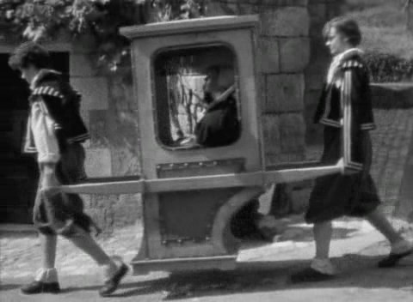
Did we enjoy when we were child?
Children have fun, but they really can not enjoy: the concept of enjoyment implies sexuality and this in children has yet to mature.
It is a small world that in which the child's claim survives into adulthood. A world where everyone "feels in right", being king, rather absolute dictators. In order to subdue others to our own reasons and never be subdued to those of others, we argue, we clash and we also enter the war.
War as insensitivity, as anaffectivity and lack of emotion. No emotions are needed to those who have just to consume, rather devour.
Surprisingly I heard a dog expert tell a lady who talked about her dog as a child, that captivity inhibits the innate aggression instinct of the beasts that are not free to copulate, that depend upon humans to be fed, perceiving humans as the head of the pack. Thus sexual inhibition, food facilitation and hierarchy make them eternal puppies. Their wagging and approaching you when you return home is not the friendship we believe in this animal, rather the innate behavior of the puppy that lasts in adulthood, through which they stimulated adults to feed them.
In the film, the children ask their father to bring them something when coming back. A rose is enough for Beauty. We find a similar behavioral root in dogs. Does that mean we're dogs?
No. It means that we are puppies, that we are still childish and our growth has stopped or has not been accomplished. We are stuck or regressed to an oral phase, phase of incorporation, where it counts more the Having rather than the Being.

Having makes us feel an ephemeral fullness, but it is not the fullness of being. Beauty’s sisters anticipate the feeling of fullness with the gifts brought back by the father on his return from the port, thanks to which they can make themselves beautiful and claim a good pretender (to have).

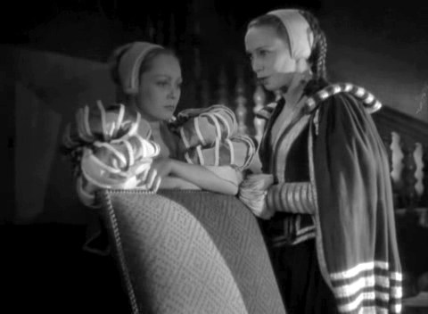
The well-being of mass society is addictive and does not let people grow, it keeps us children just like dogs. Men and the women do not reach their full humanity and remain in the devouring orality of which they are satisfied, renouncing the painful metamorphosis of growth. But if you do not grow up and think only of food (or rather of “having”) what distinguishes you from a beast?
The devouring man is a Polyphemus. Our Institute has been working for years on the myth of Ulysses, noting that the devouring of the mass man, alienated from his humanity to consume at best, has its roots already in the Greek era. The figure of Polyphemus is exemplary in this regard, a monster with only one eye that lived in a cave full of every good of god, who started to devoured Ulysses’ companions. To escape Polyphemus, Ulysses had to act with astuteness and pretend to be "Nobody".

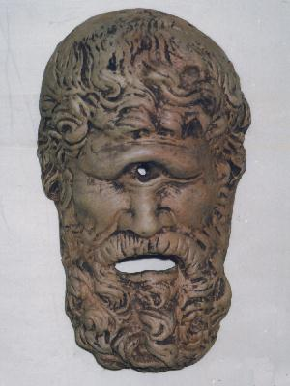
Even Beauty is cloaked in modesty, pretending to be nobody (i.e. a kitchen maid), because in a devouring society, a competitive and challenging one, there is no place for emotions, for sensitivity, for conscience, for values. You can only whisper your dreams for fear of seeing them vanish in the light of a ruthless reality that asks us to be cynical (it is cynical never to become adults for real), in which you have to be tough, with nerves of steel, with an acute and reasoning mind, otherwise you're nobody and you're worth nothing.
-Dad, bring me a rose.
The sisters tell Beauty: “See what you have done with your nonsense and your false modesty”.
Denying your envy and greed is not a good thing, it prevents us from seeing how we feed our devouring part, which grows out of all proportion and becomes monstrous.
This fairy tale teaches us that everyone bears Beauty and the Beast within herself/himself. It teaches us that unlike the common belief, the negative and positive aspects are not all in one or the other. Both of them have positive and negative aspects and these tend to transformation. It shows us that transformation, growth and desired change can not take place without merging the forces of one and the other.
Dr. I.G. Sorgi, in that far seminary of 2003, told us:
"Where do we find a Beauty that loves the Beast and wants to marry him?
The Beast is dead and in its place the Bestiality has taken over.
It is difficult to look inside ourselves and realize it, just look around and see it while acting undisturbed. Since there is no more Beauty with a deep love for the father, the Reason is DYING and in its place the rationalizing Rationality has taken over.
We all know how to rationalize, very few know how to use Reason.
THE PURPOSE of this topic? We want to listen to and question ourselves to go in search of the laws of life without which it is not possible to create and unify. "

The transformation will have to act upon Beast undoubtedly, but it is illusory to think that Beauty is, instead, perfect. She has to transform herself as well, for instance because she is poor and a servant in her own house.
The Beast has many riches and magical powers.
Beauty has only one power: love and dedication to the father. This does not make her insensitive and cynical like her brothers. But without the help of the Beast her love is powerless (it does not work), that is, she is uncapable of rescuing her objects of love (her father first and the Beast later) from the threat of death, or of rescuing herself from her miserable condition.
Not even the Beast with all its riches and powers manages to escape the threat of death, if not when Beauty decides to love him.
Loving an animal is easy, loving a beast almost. It is much more difficult to learn how to know, how to accept and love (dialectically) our own bestiality. Today, as Dr. Sorgi said, we are increasingly faced with the Bestiality and a further problem she has properly identified.
The Beast can be aggressive and this is dangerous. But Bestiality has something much more insidious; its anger is different, it is a deadly cocktail of “Ratio et Furor” (rationality an furor) (Dr I.G.Sorgi, IPAE-PPL Seminar 2013 on the myth of Medea), i.e. it is a destructive atomic bomb with a cosmic reach that does not spare anything or anyone.
It 'a beast never satiated and always thirsty for tears and blood.
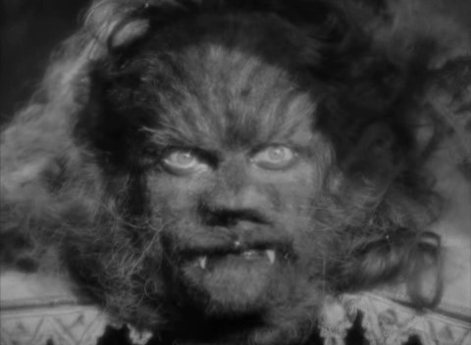
Can you think of any project from an adult perspective, if this bomb is not made armless first?
Can any business work if not even the first of the enterprises (the family) manages to prosper and wrecks miserably everywhere?
No. It can not work. What works is just the over-power of one over the other, what works is the law of the jungle where the strongest and the most astute wins, and I have to train myself to better devour the others.
You have to be well fierce where the law of the “mors tua vita mea” (your death is my life) is in force. Hence, here are the brave business captains ready to embark on global challenges, armed with insensitivity, just like the kamikaze.
Does the well-being increase for everyone? Does the global economy improve?
No, we can see more often how the gaps increase and the poverty of large sections of the population extends, the oppression of one over the other is in force.
Competition calls into question positive factors such as agonism and antagonism, as in sport, but when Bestiality prevails in people, the challenge can be turned into a "war", in hoarding. “Ratio and Furor” prevail and produce highly sophisticated cynicism and nihilism that are difficult to recognize.
You do not spot the brute in action that would be easy to recognize outside and inside of you. If you want to spot it, rather you have to look for the coldness of lucid minds (even ours) that hurt the soul and the heart because they lack every emotion; they have become automata programmed to smooth their way at any cost, without ever saying thank you, without ever realizing the unhappiness they can sow.
They do not know that the beast devours them (hate and envy) and never accept that they are wrong or fail. They are hostages of a serious inability to face the painful crises and the change that life asks of us all and they are thirsty for revenge. But they do not know it.
All this can not leave us indifferent, defenseless, renouncing to believe in values. Beauty's love for her father is to express this. Beauty does not want to give up growing and loving. She knows that harmony and concord are a precious patrimony to cultivate for oneself and for others. Instead of sowing discord, she decides at some point to face the Beast, to defeat her bestial part and become better.
"In human beings, however, there is reason, intuition and artistic power to create. Every beauty has various forms, but a beauty we can not buy is that which comes from the synthesis of the rational and the irrational.
Every artist creates beauty and in order to do so she/he has to face a painful anguish.
Each of us has the Beauty part as well as the Beast part and we will try with these parts to create a NEW BEAUTY that comes from the fusion of all the energies we are endowed with. "
2003, I.G. Sorgi
CREATIVE WRITING WORKSHOP
The conflict in the family, with others, in the workplace, with collaborators, in the enterprise

Guide
What is a conflict?
As the title of this workshop suggests, there are many types of conflict and they are both internal to the individual and external: conflicts of individuals or multitudes, cultural, commercial and sentimental conflicts.
Therefore a unitary definition of conflict can not exist.
The most extreme and virulent example of external conflict is war.
Inside us a conflict can manifest itself in many ways, for example when a person sets himself a goal but then, in reality, takes another direction: she would like to realize a dream, her needs or desires but she is uncapable. The intention is disconnected from the action. Maybe she says: "I want to lose weight" but she continues to eat too much and badly; or she thinks "I want to be kind to others" but then her character intemperance takes over; or she says "I love you" but she can not leave the other one.
The conflict is inside and outside of me. To see it outside is easier, to see it inside a little less, even though myriad of psychological and psychoanalytic studies have tried to study and illustrate it.
What to do? How to avoid falling into a conflict?
We have been taught that we have arrive at the essence, that is, we have to grasp the truth, unmasking what is not true: appearance and lie.
Then we have been taught that the conflict ends only if one of the two sides has the courage to admit to be wrong.
It is an appearance that Beast is ugly and scary (it turns out to be a person eventually). Beauty, in spite of the fear, does not let herself be discouraged and approach him, discovering at first that he has many powers and riches and at the bottom is also good.
Despite this, Beauty can not keep her promise to Beast when she leaves to go back to her father. Once back home, she let herself be persuaded by her envious sisters to stay home more than a week, thus endangering the life of Beast.
Conflict is nourished by ambivalence: I want but I can not ... I can but I do not want to.
Now with regard to conflicts we will look for our own truth and will translate it into an artistic form, trying to do like the director Jean Cocteau in this movie which is writing through images.

We will find out that the images are evocative and for sure we’ll be able to represent also yours in a performance of what we call Anthropoartistic Theater Dance, which you will experience in the coming days.
Dr. Simone Angelini will then help you, to reflect and rework your productions, the leap and the difficulties you will encounter in writing. You will learn the magic of this "magic mirror" (creative writing) that shows you your thoughts, never banal, even when they seem so. And this will be a good dose of confidence that is much better than the ephemeral security that like Adelaide, Felicita and Ludovico in the film, we often look in the wrong place.
Now through creative writing, we experience the magic power of the mirror within us, and how the mirror shows us our thoughts.

The gifts of the Beast
The Beast has five magical powers and he gives them as gift to Beauty. They are:
- the magic horse
- the mirror
- the fairy glove
- the golden key of the Diana pavilion (goddess of war) where all the beast riches are kept.
- the Rose
What can these donated powers mean?
Do we have the same gifts and powers?

A first gift we have is this meeting, made possible by the fact that you can go wherever you want.
We have legs, we have trains and planes. We are able to move, thanking God, to be alone or to go to others when we want to and can.
Beast’s magic horse brings both the father and Beauty back home.
In Beast’s house there are no people, but just self-propelled things. In Beauty's house there are more people who are not at all close-knit; every communication among them generates sparks or is inhibited, they are all taken and busy by their facts, as we said.
Singularity on the one hand, multiplicity on the other.
The first is disturbing for solitude, the second is disturbing for the lack of harmony and chorality in the group of people.
Even here we are a group of people, those who are present and others that you can not spot, but are there. They really are!
Who can’t we spot or want to believe we cannot spot?
Even if not physically, the persons who made this training project possible are with us, our teachers who stimulated and guided us towards the love of knowledge, our parents who brought us to life and made it possible , the teams that with their partnership made the proposal approved for funding and made it possible, our beloved ones who let us go, waiting for our return ....
Did you think of this? Can you spot how many relationships are needed to make a single moment possible, a single moment that opens up new possibilities? To us, the task of recognizing the complexity, the communicative, emotional and relational constellation active at that moment. If we do not recognize it, if we do not think about it then we are self-centered, those who take everything for granted, i.e. that everything is due and we can not recognize the gifts that life gives us, because it is not given there are some: nothing in life is granted.
It is a creative power to recognize the gift, because it is not a present that is clearly visible. The gift is love for life, first of all, and it requires intimate understanding and ability to navigate the deep sea of ​​life (as Dr Gabriella Sorgi says). If you see the gift, if you appreciate it and cultivate it like a rose, you can also spot new possibilities where others can not spot anything. Beauty's father, for instance, steals the rose and does not ask for it as a gift, he does not see the gifts he has already received and is almost escaping from the castle, as if he were a thief. In fact, if we are not able to perceive life as a gift, we will live life as a theft.

Bibliography:
I.G. Sorgi, Viaggio all’interno dell’anthropos: il mare profondo della vita, Ed. Terzomare 2010
I.G. Sorgi, Pennellate di vita sulla pelle, Ed. Terzomare - 2009
I.G. Sorgi, La stanza di Sophia, Ed. Terzomare -2010
I.G. Sorgi, A me non piace la cioccolata, Ed. Terzomare -2011
I.G. Sorgi, LIVE, stampa in corso
AA.VV. Atti I° Congresso IPAEA “Nascere! E poi?, Edizioni Discobolo1986
AA.VV. Atti II° Congresso IPAEA “Europa verso il 2000. Come dare un'anima agli europei" edizioni IPAEA- 1990
I.G. Sorgi,Pennellate di vita 1 - Atti dei Laboratori di Scrittura creativa 1996-1999
I.G. Sorgi, Pennellate di vita 2 - atti dei Laboratori Creativi sulle leggi della Vita anni1998-2001
I.G. Sorgi, Pennellate di vita 3- Atti dei Laboratori Creativi sulle leggi della Vita anni 2002- agosto 2003
I.G. Sorgi, Pennellate di vita 4 - Atti dei Laboratori Creativi sulle leggi della Vita settembre 2003- febbraio 2004
I.G. Sorgi, Pennellate di vita 5 - Atti del Laboratorio creativo sulle Leggi della Vita Supetar agosto 2004
I.G. Sorgi, Pennellate di vita 6 - Raccolta di relazioni magistrali a congressi - anni 1984-2007
I.G. Sorgi, Pennellate di vita 7 - Raccolta Chiavi di lettura dei Laboratori creativi sulle leggi della Vita - anni 2005-2007
I.G. Sorgi, Pennellate di vita 8 - Raccolta Chiavi di lettura dei Laboratori creativi sulle leggi della Vita - anni 2008-2010
AA.VV. Atti III° Congresso IPAEA “la coppia nel 3° millennio: Penelope la trasformazione della vendetta”. edizioni IPAEA – 2004
AA.VV. Atti IV Congresso IPAEA “…senti? …a proposito del padre e…della sua gravidanza” edizioni IPAEA – 2006
AA.VV. Atti V Congresso IPAEA “Ma dove vanno i ragazzi di ieri, di oggi e di domani? Scienza e cultura, arti che si incontrano tra Mito e Realtà”Ed. IPAEA 2011

A. Mercurio, La Sophia-analisi e il principio della gioiaEditore Carra– 2011
A. Mercurio, Antropologia esistenziale e meta psicologia personalistica, Ciampino, Ed SUR, 1998
A. Mercurio, Teoremi e assiomi della Cosmo-Art, Ciampino, Ed. SUR, 2004
A. Mercurio, Amore e Persona3^ Ed. Costellazione d'Arianna - Roma 1993

A. Mercurio, Teoria della Persona, 2^ Ed. Costellazione d'Arianna - Roma 1992
A. Mercurio, Amore Liberta' e Colpa Psicoanalisi e Cristianesimo a Confronto, 2^ Ed. S.U.R. - Roma 1999
A. Mercurio, La Vie Comme Oeuvre d'art, Ed S.U.R. - Roma 1988
A. Mercurio, Teoria dell'inconscio Esistenziale, Ed Costellazione d'Arianna - Roma 1995
A. Mercurio, Le Leggi della Vita, Ed S.U.R. Roma 1995
A. Mercurio, La Vita come Opera D'arte e la Vita come Dono spiegata in 41 Film, Ed S.U.R. Roma 1995
A. Mercurio, Gli Ulissidi. Il teorema ed il mito per navigare da un universo all'altro, Ed S.U.R. Roma 1997
A. Mercurio, La Sophia Analisi e l'Edipo, Ed S.U.R. Roma 2000
A. Mercurio, La Nascita della Cosmo-Art, Ed. S.U.R. Roma 2000

